GUIDELINES AND TEMPLATE FOR THE SUCCESSFUL SUBMISSION OF “FRONTIERS IN BIOMEDICINE” CONFERENCE EXTENDED ABSTRACT
A. Author^{1*}, B. Second author^{1,2}, C. Third author²
¹ Organisation, City, Country, Position
² Organisation, City, Country, Position
* Corresponding e-mail: xxx@xxx.xxx
Summary. A short summary of your contribution should be inserted here. Use short, direct sentences. It should be as concise as possible, complete, self-explanatory and without reference to the paper itself. The summary should also be informative, giving the scope and emphasizing the main conclusions, results, or significance of the work described.
Key words. Include 5-10 keywords here.
INTRODUCTION
This document provides the guidelines and template for “Frontiers in Biomedicine” conference extended abstract. Please, follow the instructions carefully.
SIZE, TYPE AREA, MARGINS, FONTS AND HEADINGS
Please, use MS Word or similar word-processor to prepare a conference proceedings paper. The total extended abstract size should not exceed two A4 (210 mm × 297 mm) pages, including coloured figures, tables, etc. Please, use single line spacing throughout the paper.
The template below has margins set for: inside, outside, top and bottom – 2 cm and header.
For the title of the paper use: 14 pt, Times New Roman bold; start at top of page, centred, capitalized, 12 pt space above and below.
For author's names use: 12 pt, Times New Roman, centred, italic, 12 pt space below.
For author's affiliation use: 12 pt, Times New Roman, centred, no space above or below.
For Summary and Key words use: 10 pt, Times New Roman, justified, 12 pt space above and below. Make the word Summary and Key words bold followed by a point.
For Headings and Subheadings use:
- HEADING 1:
12 pt, Times New Roman, bold, left aligned, capitalized. 12 pt space above and below.
Please, note that articles are supposed to have standard main headings as “INTRODUCTION”, “CONCLUSIONS” and “REFERENCES”.
- Heading 2:
12 pt, Times New Roman bold, left aligned, initial capitals for the words followed by lower case, 12 pt space above and below.
- Heading 3:
12 pt, Times New Roman, italic, left aligned, 6 pt space above and below.
For main text use: 12 pt, Times New Roman, justified, with 6 pt space above and below. Do not separate paragraphs with blank lines!
EQUATIONS
Please, use Equation Editor to create displayed equations. They should be centred and numbered. Below is an example created with Microsoft Equation 3.0:
. (1)
FIGURES
High resolution illustrations should be included directly in the files you submit. All illustrations must be numbered in order of appearance. Each figure name should include its number (along with the abbreviation "Fig.", bold) followed by a short description (caption) as shown in the example below. For the figure caption use: 12 pt, Times New Roman, centred, italic. The size of a figure should be commensurate with the amount and value of the information the figure has to convey. Centre figures on the width of the page.
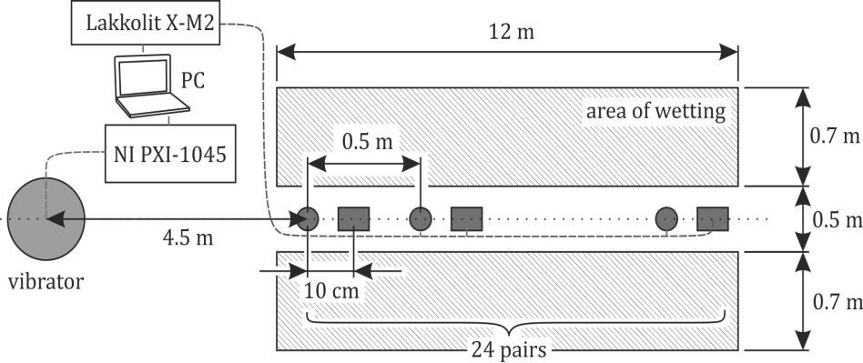
Fig. 1. General scheme of measurements. Small circles and rectangles correspond to the positions of vertically and horizontally oriented geophones, a large circle – to the position of the source
TABLES
Tables should be numbered consecutively (by analogy with figures) and centred on the page width. Table headings should be placed beneath tables: 12 pt, Times New Roman, centred, italic. Avoid vertical lines where possible. Detailed explanations or entries should be typed directly.
REFERENCES
Please, make your references list in accordance with the example below (please, notice that it is represented in alphabetical order). Do not force the "References" section to start on a new page.
FINE TUNING
Do not end a page with a heading or subheading.
Do not end a page with one or more blank lines, except to avoid "widow" headings and to end your paper.
Do not underline headings, subheadings, title, figure captions and table headings.
Keep footnotes to a minimum or put them in a special section before the References.
Page numbers should be absent. They will be added later by publishers.
PERMISSIONS AND COPYRIGHT TRANSFER
You are responsible for obtaining the necessary permissions to quote or reproduce material, including figures, from already published works, and to reprint from other publications. An appropriate credit must be included. Neither the “Frontiers in Biomedicine” conference organizers nor the publishers are responsible for clearing any permissions on your behalf.

